m



Pull Request Setup Process



Document Control Information
Document Information
Document Name | Pull Request Process
Project Name | Humana Salesforce DevOps
Client | Humana
Document Author | Krishna Prasad Polukonda
Document Version | 1.0
Document Status | Pending
Date Released | 2/16/2023
Document Edit History
Version | Date | Additions/Modifications | Prepared/Revised by
Document Review/Approval History
Date | Name | Organization/Title | Comments

Table of Contents
1. Pull Request Prerequisite Setup for Developers 4

2. Pull Request New Process 5

3. Updates on existing PR’s 8

Pull Request Prerequisite Setup for Developers
For setting up Second Level Approval on the ADO
- Go To ADO à Click on the Project for which you would like to add this rule for second level.
- Click on Project Setting from bottom left of the page.
- Click on Repositories under “Repos” Section.
- Click on which repository you would like to add this rule.
- After clicking on a repository à Clik on “Policies” Tab.
- Scroll down to “Branch Policies” à click on any branch where you would like to add policy
- Scroll down to “Automatically included reviewers” section à click on “+” under that to add a policy.
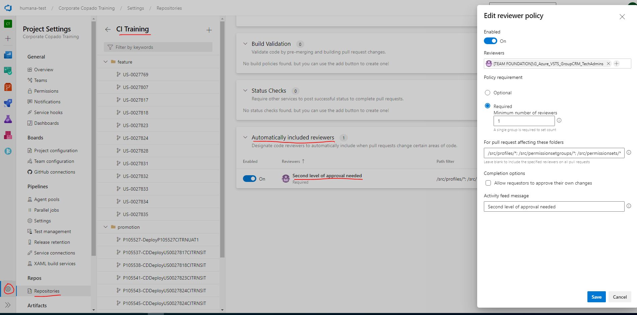
Data to Enter:
- Reviewers : New Group for the team who will be be part of approving the security changes.
- Policy requirement: Minimum number of reviewers should be always “1”.
- For pull request affecting these folders: /src/profiles/*; /src/permissionsetgroups/*; /src/permissionsets/*
- Activity feed message: Second level of approval needed.

Pull Request New Process

- This feature will enhance pull request from being self approvals and also this would enable Second Level approval workflow and normal approvals in azure in one place to get the PR approved in Copado.
Below are the steps to create a pull request in Copado.
- Go To User Story and Click on the “Open Pull Request” from the Button towards top right.
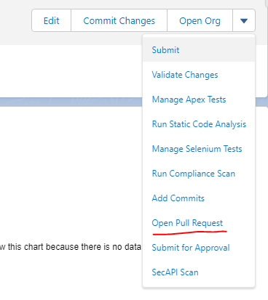

- After Clicking on Open Pull Request, you will be redirected to Azure in new tab.
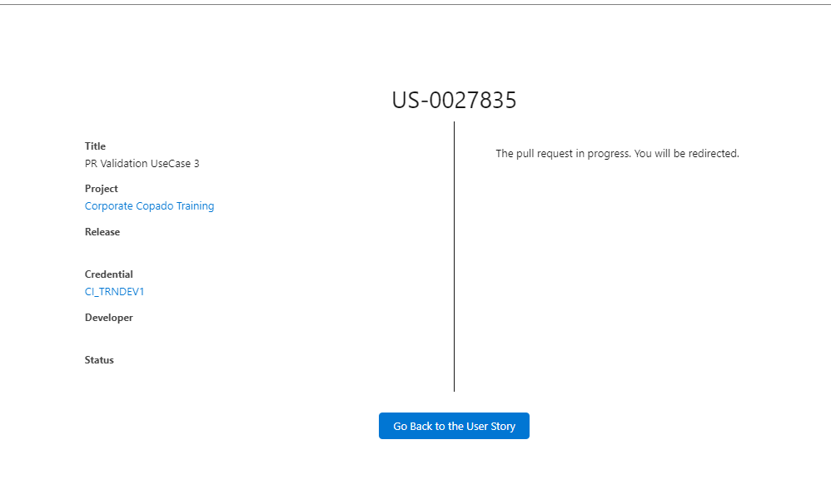
Azure Tab for Creating the PR:
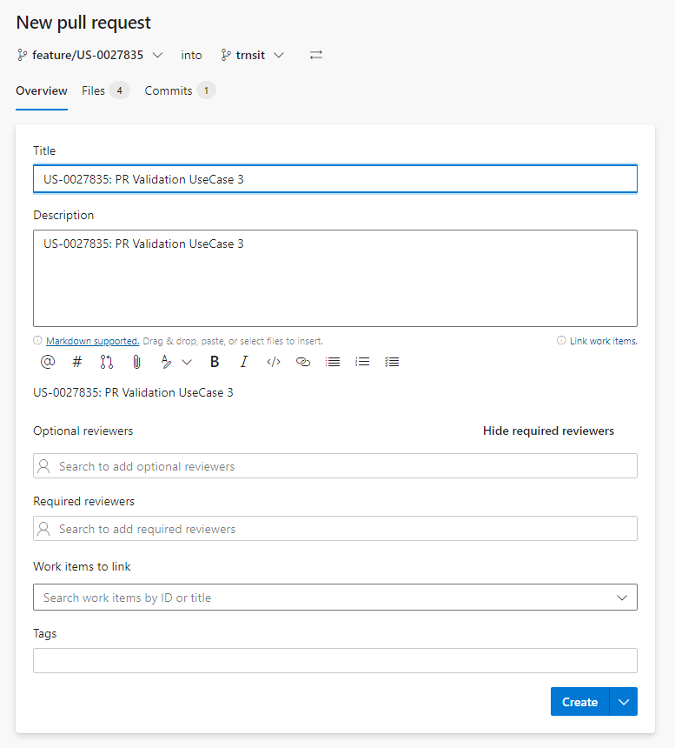
- Once the PR is created in Azure, and upon clicking “Go Back to User Story”, Click on the Related Tab and scroll down to Pull Request Section to see the PR which you have created in Azure.
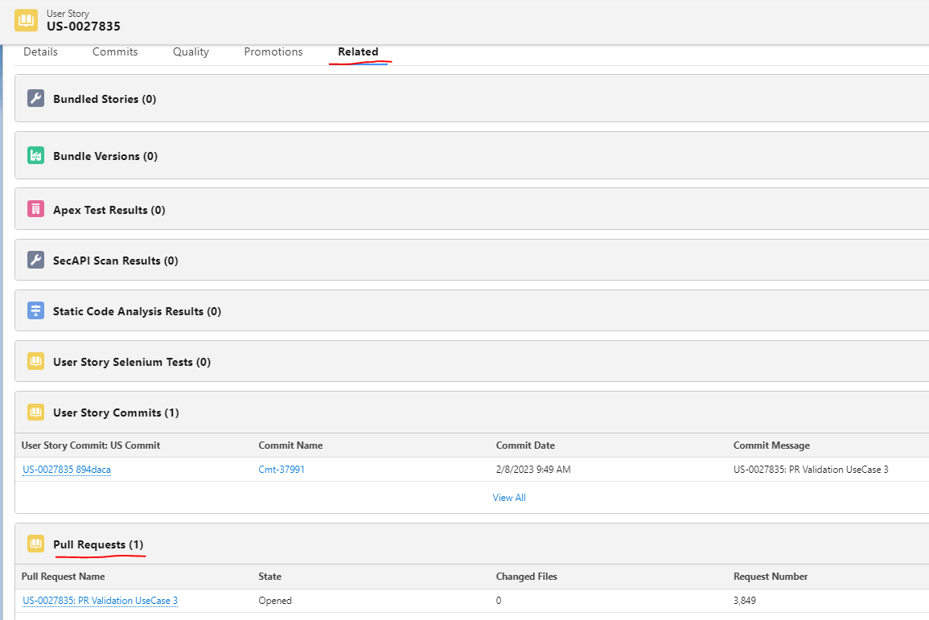
Note: Make sure required approvers are added while creating the PR based on the Branch policies set up for the Target branch.
- Once the PR is approved in ADO, all those approvals will be floating into Copado and marks the PR from opened to approved once all required approvals are completed in ADO.
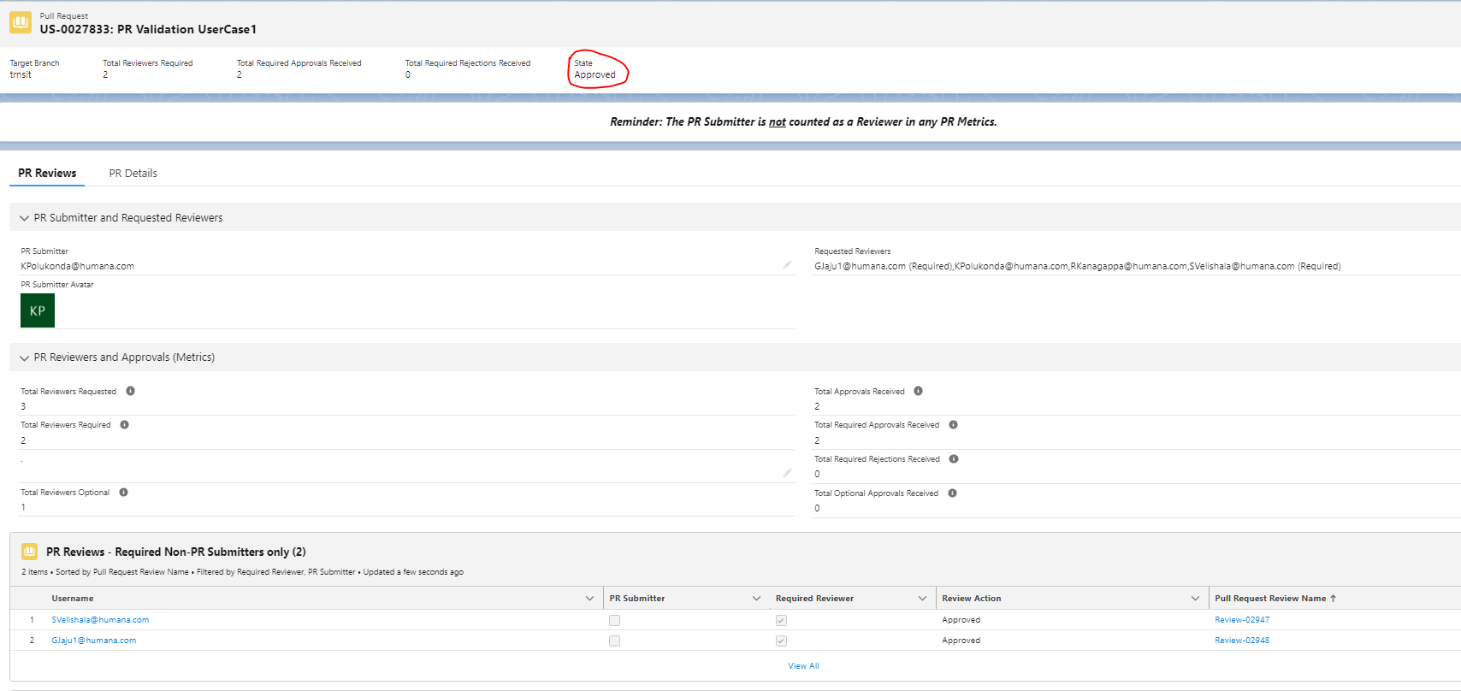
- From Detail if you go back to the User Story, you will see the “Pull Request Approved” checkbox will be check once the PR is fully approved.
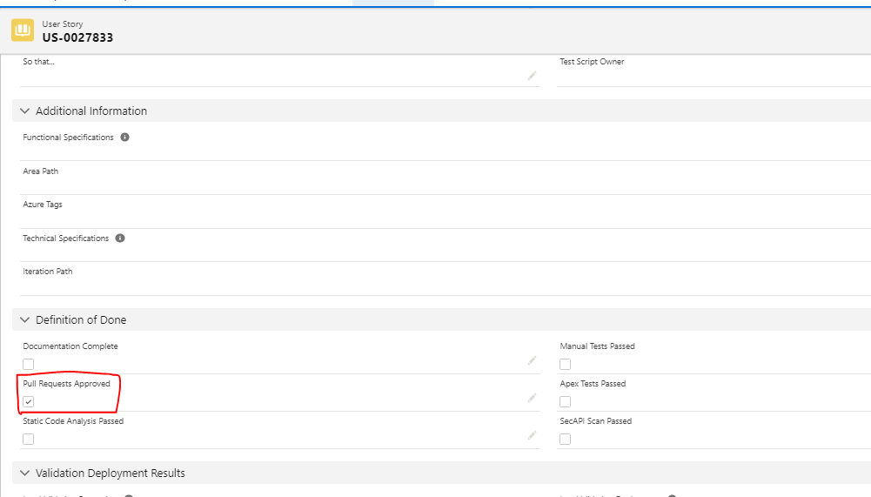

Updates on existing PR’s
- When you add additional reviewers on the PR which is already open
Copado:
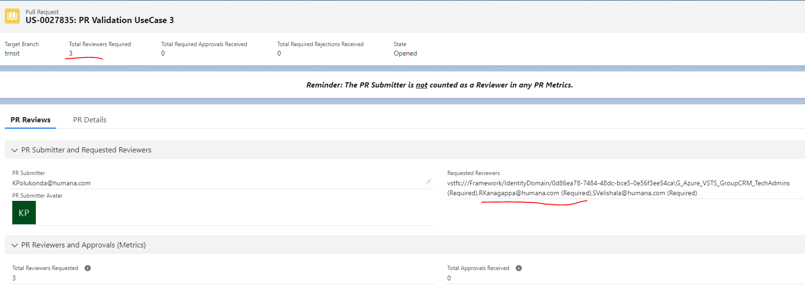
ADO:
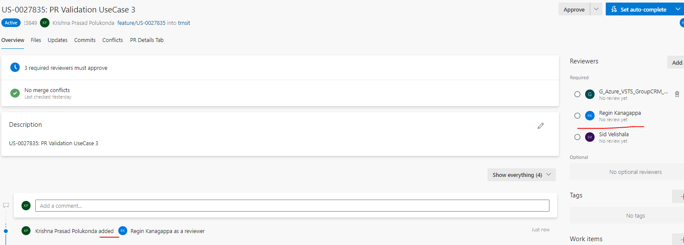
- Removing existing approvals:
Before COPADO:
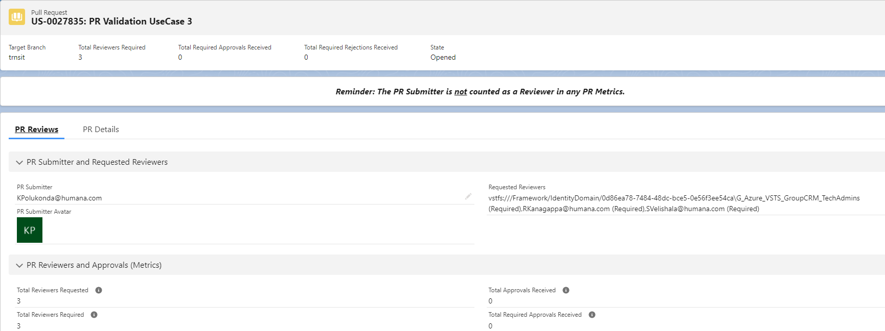

Before ADO:
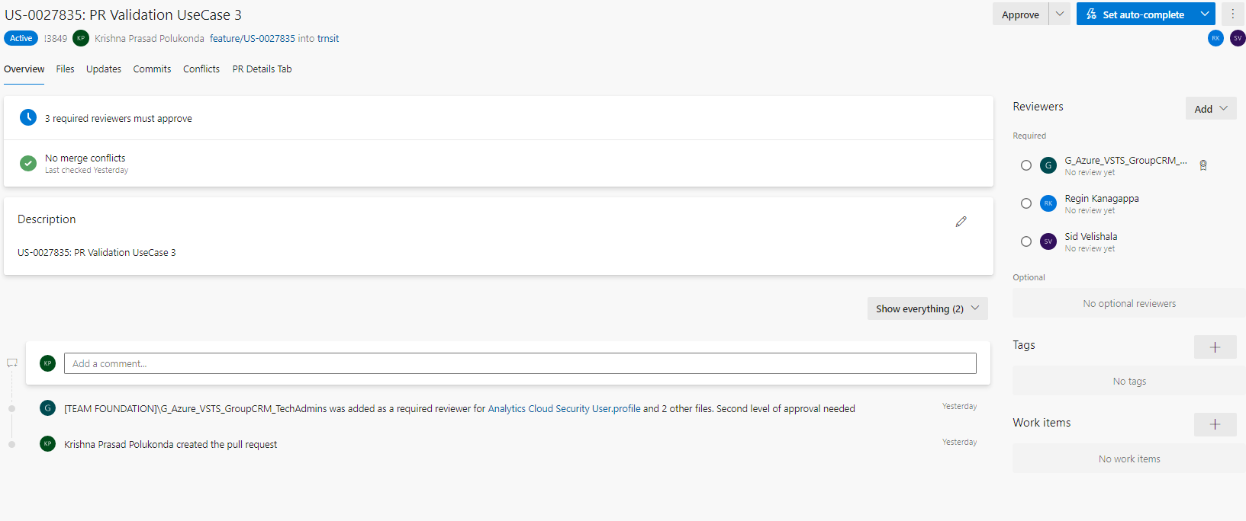

After Removal in Copado:
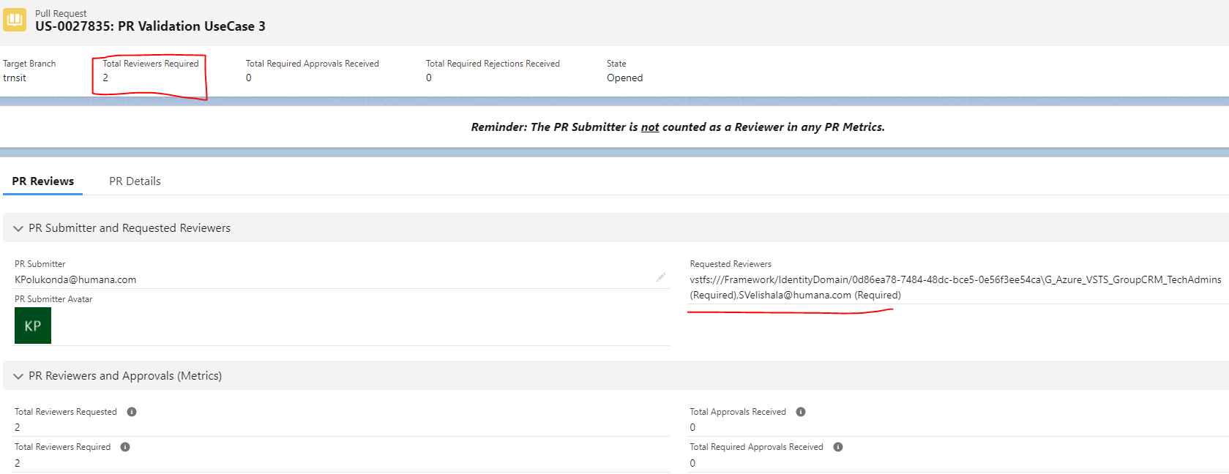
After Removal in ADO:
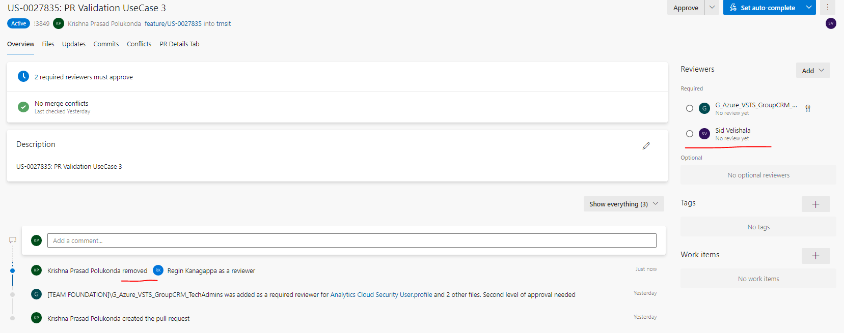

Note: If PR is approved in Azure DevOps PR link and Copado PR status is still “opened” and doesn’t update as “Approved” then Abandon the PR and create a new PR and add the required reviewers while creating the new PR. Status will check these 2 values below.
